Macintosh HD:Users:dvargas4:Desktop:logo.png

**Final Exam**

**NWIT 275 (Wireless Security)**

**2025 Summer 2**

**Instructions:**

* Answer the questions below using this document (do **NOT** convert to PDF).
  + Include your last name in the name of the document.
* Answer all questions using the .PCAPNG file provided.
* Return the ANSWER SHEET **ONLY** to the instructor via email at [david.vargas@montgomerycollege.edu](mailto:david.vargas@montgomerycollege.edu) by 11:59 PM on Sunday Aug 197, 2025.
  + ***Late submissions will not be accepted.***
* Students are to work independently. There is to be no collaboration. Any evidence of collaboration will result in a formal Montgomery College charge of academic dishonesty.
* ***Sharing any of the contents of this exam will be considered a violation of the MC Student Honor Code.***
* Failure to follow instructions will result in point penalties.
* Additional research may be required to answer some questions.

**Required File:**  *NWIT275FinalExamPCAP.pcapng*

***Good luck!***

**ANSWER SHEET**

**Student’s Name:**

**Questions:**

1. Was the traffic in the packet capture file captured in managed or monitor mode? Explain your answer. **[1 point]:**

**Answer:**

1. Which company manufactured the access point used by “Starbucks WiFi”? **[1 point]:**

**Answer:**

1. Is it possible to determine the manufacturer of the access point(s) used by the “Potomac RF Gun” WLAN? Provide proof to justify your answer. **[1 point]:**

**Answer:**

1. Is there more than one MAC address associated with the Potomac RF Gun WLAN? If so, list a few. **[1 point]:**

**Answer:**

1. Does the packet capture contain any traffic from a Ubiquiti access point? If so, what is the destination address of the packet(s) generated by this AP? **[1 point]:**

**Answer:**

1. What kind of hardware device and what is the manufacturer of the device that most likely generated packet #9117?

**Answer:**

1. What kind of wireless frame is packet #11620? What is its purpose? **[1 point]:**

**Answer:**

1. Do the SSIDs in the packet capture provide any clues to the physical location where the packet capture was performed? If so, in which Maryland down was the capture performed? **[1 point]:**

**Answer:**

1. Is there evidence of interference in the packet capture? Explain your answer. **[1 point]:**

**Answer:**

1. Which two channels is “Starbucks WiFi” using? **[1 point]:**

**Answer:**

1. What is the most commonly used channel in the packet capture? **[1 point]:**

**Answer:**

1. Which frequencies are used by the WLANs in the packet capture? **[1 point]:**

**Answer:**

1. What are the highest and lowest data rates of the WLANs in the packet capture? **[1 point]:**

**Answer:**

1. Which protocol is displayed in the “Protocol” column of the packet capture? **[1 point]:**

**Answer:**

1. What kind of wireless management frame is packet #1912? Explain the purpose of this frame. **[1 point]:**

**Answer:**

1. Which wireless management frame would be the response to packet #1912? **[1 point]:**

**Answer:**

1. What kind of wireless management frame that is displayed below? Explain the purpose of this frame. **[1 point]:**

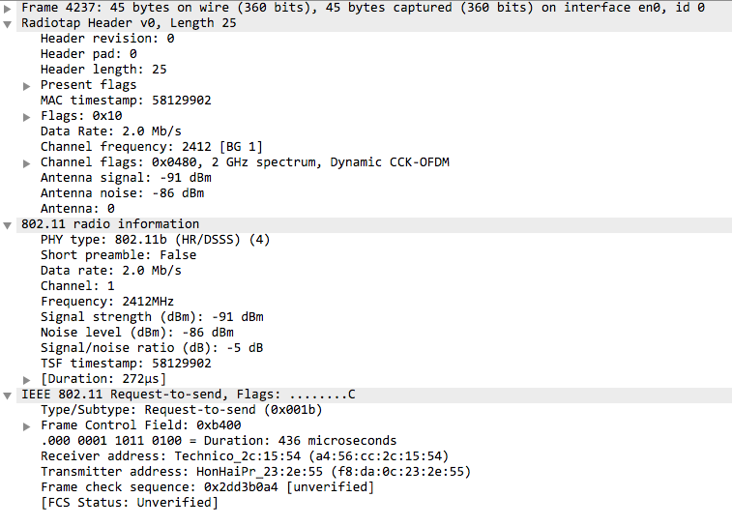

**Answer:**

1. What kind of wireless management frame that is displayed below? Explain the purpose of this frame. **[1 point]:**

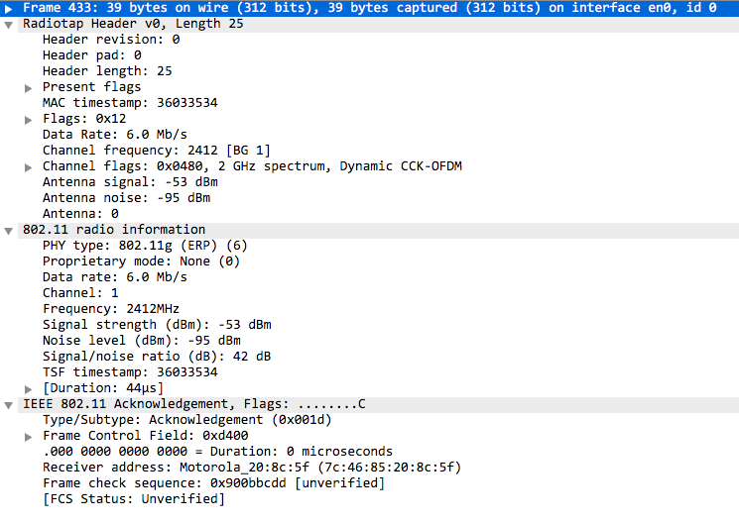

**Answer:**

1. What is the SSID of the wireless management frame displayed below? **[1 point]:**

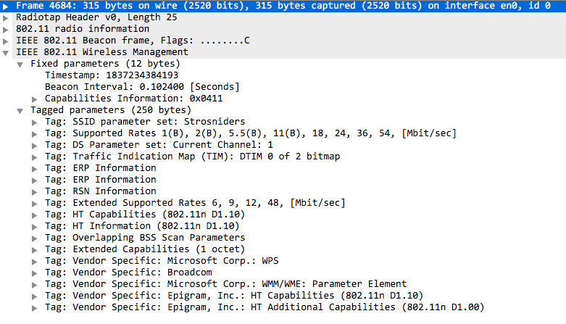

**Answer:**

1. *One free point. Enjoy the break!*

***Done!***